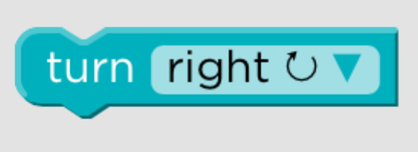 | Turn right
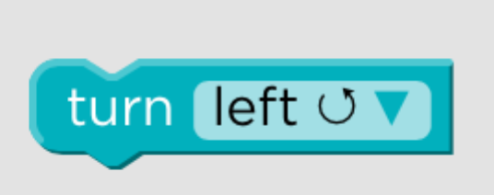 | Turn Left
 | Move forward 1 square
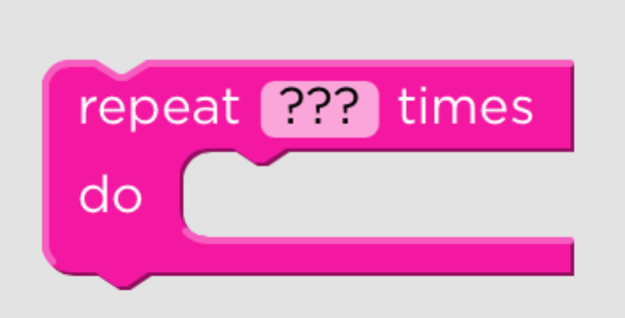 | Repeat the code blocks inside ??? times  You need to decide how many times
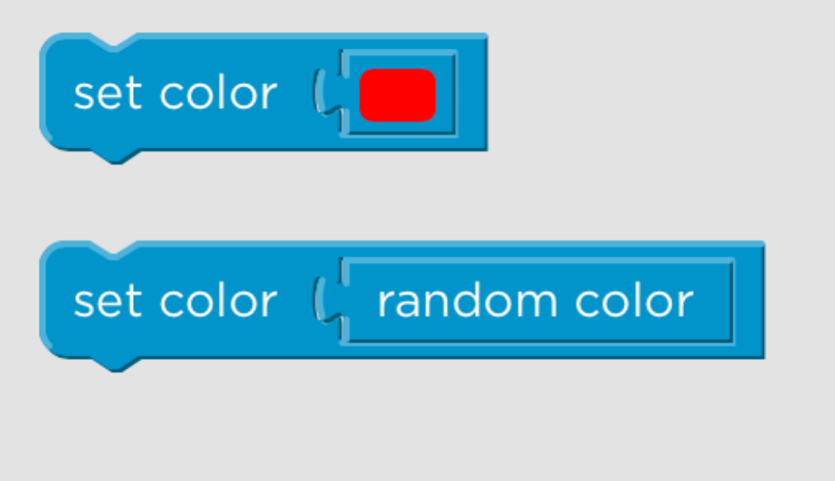 | Set the color of the pen [you decide what color]  Set the color of the pen to random
 | Move forward/backward by XXX Pixels. You can change the number of pixels
 | Turn right/left by XXX Pixels. You can change the number of pixels
 | Jump forward/backward by XXX Pixels. You can change the number of pixels
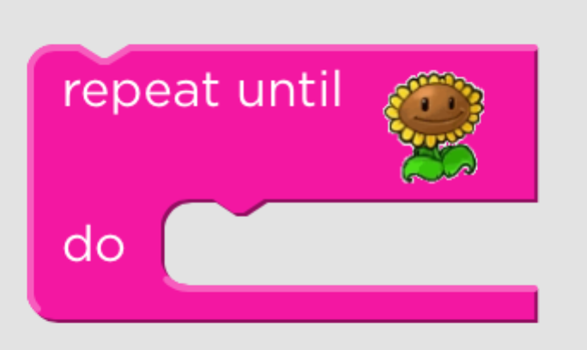 | Repeat the coding blocks inside the REPEAT UNTIL block until you get to the end point.
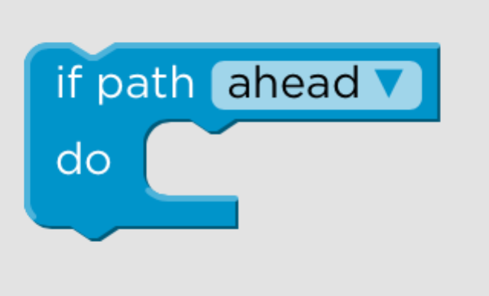 | If there is a path ahead/left/right do the following
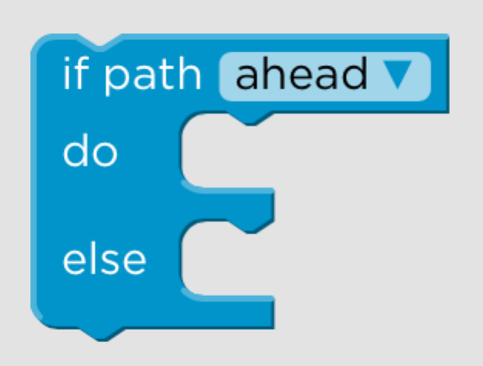 | If there is a path ahead/left/right do the following OR do…..

