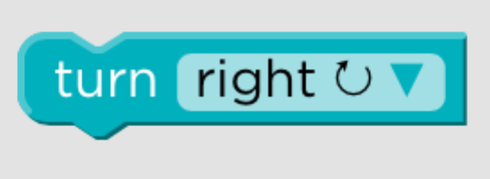 | Turn right
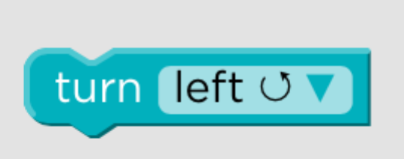 | Turn Left
 | Move forward 1 square
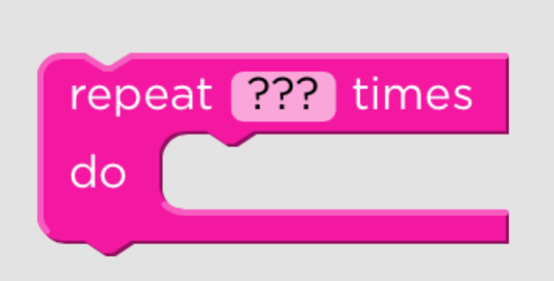 | Repeat the code blocks inside ??? times  You need to decide how many times
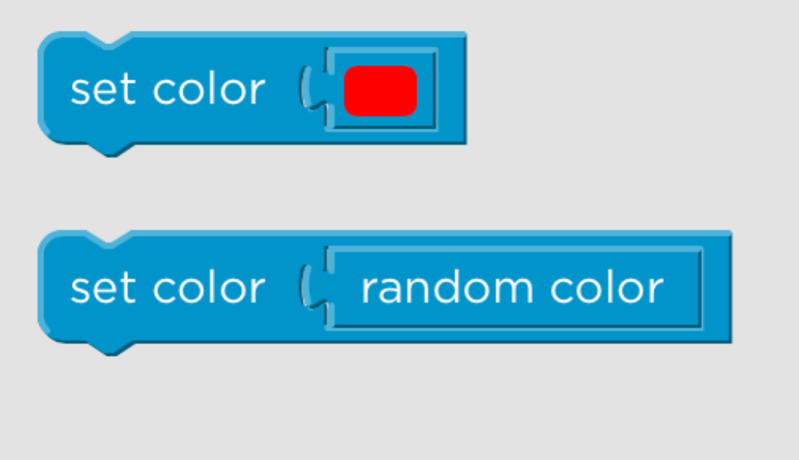 | Set the color of the pen [you decide what color]  Set the color of the pen to random
 | Move forward/backward by XXX Pixels. You can change the number of pixels
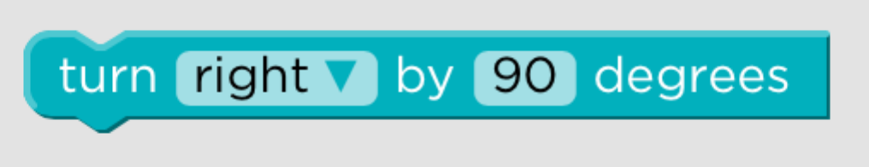 | Turn right/left by XXX Pixels. You can change the number of pixels
 | Jump forward/backward by XXX Pixels. You can change the number of pixels
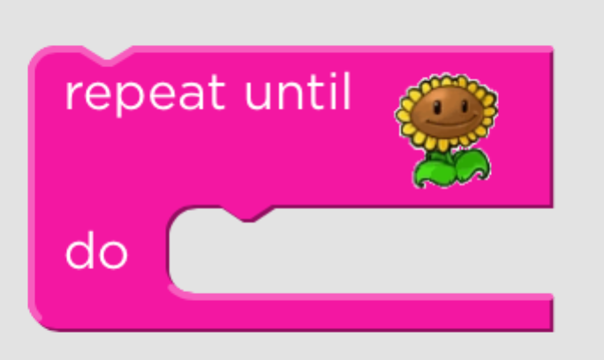 | Repeat the coding blocks inside the REPEAT UNTIL block until you get to the end point.
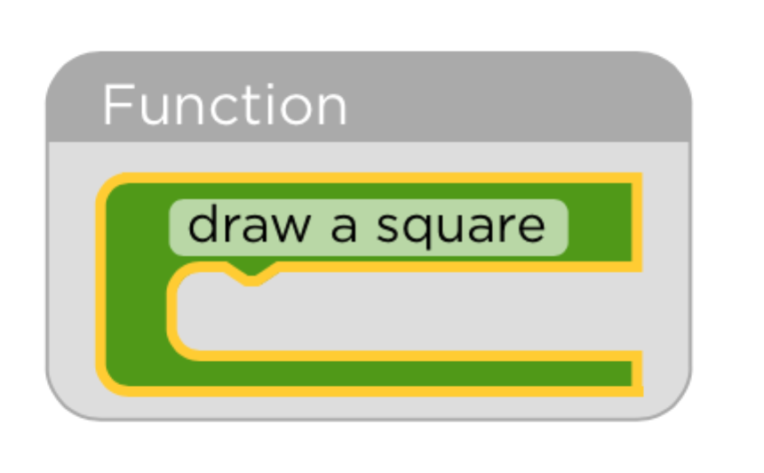 | Draw a XXXXX function. All the code inside the function will be used to draw the shape
 | This calls the function
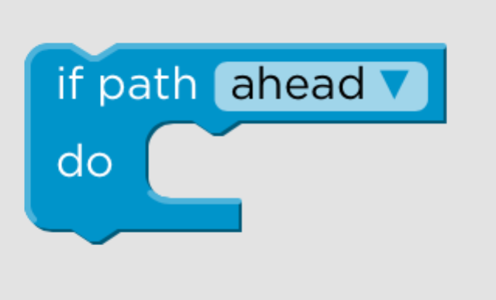 | If there is a path ahead/left/right do the following
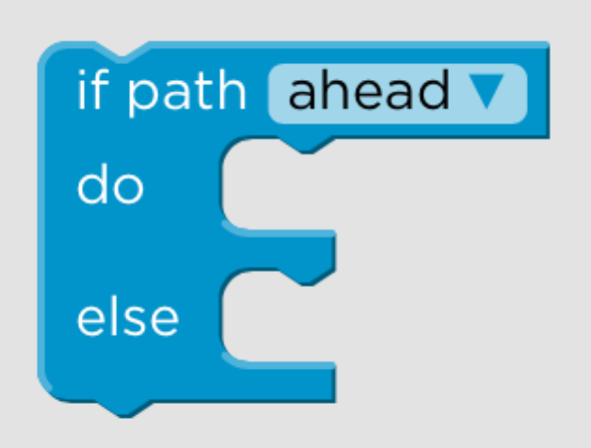 | If there is a path ahead/left/right do the following OR do…..
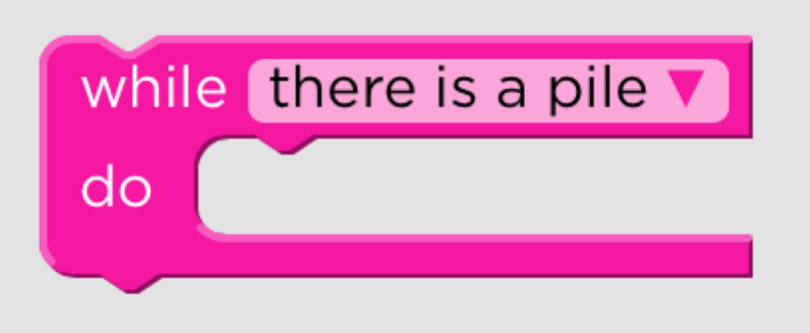 | While there is XXXXX do….
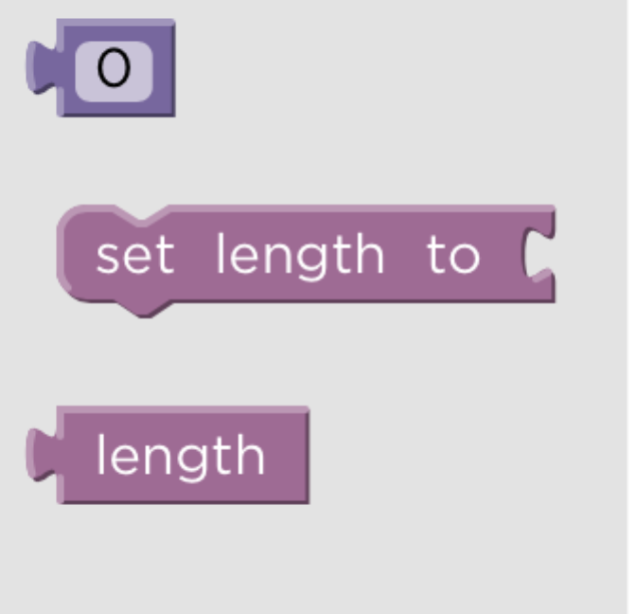 | Allows you to assign a value to the variable ‘length’  Creates a variable called ‘length’  Allows you to use the variable length somewhere else in the coding
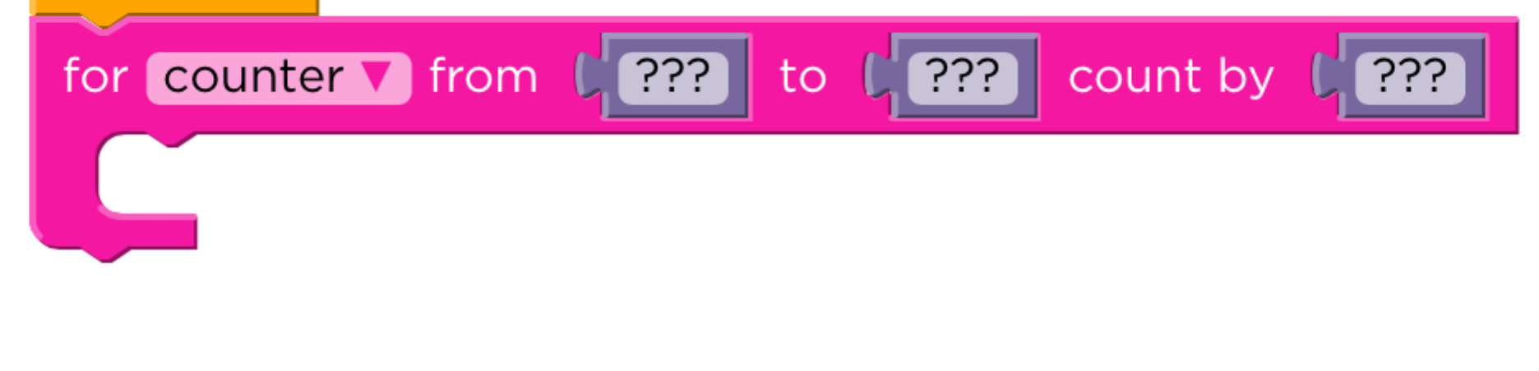 | Creates a counter that will count from ???? value to ???? value, counting by ???? amount.  The code blocks will be done inside the counter loop

